What we have learned…
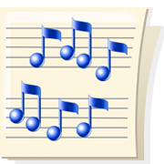
in Kindergarten Music

May

Kindergarteners have spent much time on learning new songs to sing and play games. We will be using this song repertoire to teach more concepts in 1st and 2nd grades.

We have learned concepts of style - fast/slow and loud/soft. These concepts are important to music listening as we study more music works over the next few years. Students have learned these basic words to describe all types of music.

We have learned that music has high and low sounds. They go up and down to create a unique melody for each song we sing. We will continue to learn how these sounds make a melody in 1st grade.

We will continue the concepts of beat and rhythm throughout elementary music. We have named and practiced beat and continue to explore the ideas of long and short sounds that make up the rhythm of the music.

There is much more to learn and we move on to 1st Grade! See you there!!

Ms. Weber

