What we are learning…
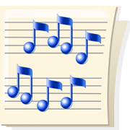
in 2nd Grade Music

November

Second graders have been reviewing many concepts from first grade; beat, rhythm, form and the melody pitches of so, mi and la. We have learned that some of our sounds take only a step to get to, while others jump.

We have been learning new songs and games. I’m sure you have been hearing a few of them at home. We are getting ready to learn a new rhythm and are using our Music Folders to practice writing music. We will be learning to write our new songs soon.

Our newest project is studying “The Nutcracker” by Peter Tchaikovsky. We have read the story and are listening to the music to learn about instruments and musical elements like: tempo (fast and slow), dynamics (loud and soft), meter (beats grouped in 2, 3, or 4) and style (smooth or jerky).

