What we are learning…
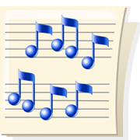
in 1st Grade Music

August

We are reviewing movements to songs, classroom expectations and games that have us walk together in a circle.

This month we have been focusing on Steady Beat. Your children have been patting the beat to many of their favorite songs and some new ones. We have been patting on our heads, shoulders, legs, clapping and putting the movement in our feet. We have been touching pictures to our songs. Ask your child what his/her favorite song is.

Now that your child is in 1st Grade, he/she will have a Music folder and book that we use to learn more about our favorite songs. Ask your child what color of folders his/her class is.

